**Description: OC_Masterbrand_CMYK.eps**

in partnership with

****

ICT40515 Certificate IV in Programming

Develop a UI to interact with a database

**SP6/Module 9 Assessment**

ICTPRG403 Develop data-driven applications

ICTICT420 Develop client user interface

ICTPRG410 Build a user interface

Assessment: 33130/03

*© Open Colleges Pty Ltd, 2016*

*All rights reserved. No part of the material protected by this copyright may be reproduced or utilised in any form or by any means, electronic or mechanical, including photocopying, recording, or by any information storage and retrieval system, without permission in writing from the copyright owner.*

*All terms mentioned in this text that are known to be trademarks or service marks have been appropriately capitalised. Use of a term in this text should not be regarded as affecting the validity of any trademark or service mark.*

**Assessment task 33130/02**

## Introduction

This assessment will test your skills and knowledge gained through completing the learning and activities in **Module 9: Develop a UI to interact with a database.**

This is a three-part assessment.

In the first part of the assessment, you will analyse a requirements brief to design and develop user interfaces for a number of screens.

In the second part, you will write code for the screens developed in the first part of the assessment to connect and interact with a database.

In the third part of the assessment, you will answer a number of questions, which will test your knowledge on developing and building a user interface, and developing a data driven application.

**Note – you must successfully complete ALL assessments (33130/01, 33130/02 and 33130/03) to achieve competency in:**

***ICTPRG403 Develop data-driven applications***

***ICTICT420 Develop client user interface***

***ICTPRG410 Build a user interface***

**Short answer questionnaire**

Answer each of the twelve (12) questions. Do not write more than 100 words for each question.

Rename this document to: StudentNumber\_UIDB\_33130-03.docx. For example, 665437\_UIDB\_33130-03.docx.

Provide answers in the space under each question.

1. Detail considerations of UI design regarding batch procedures.

Answer:

Is where a process is started and locked until it is completed. There are two stages to consider here, pre-batch and during the processing. Pre-batch would require a user to prepare or enter all relevant information prior to starting (1). Historically (and from personal experience), computers would be locked until finished, but advances in operating systems and computer hardware, the user is generally able to continue working in other areas. The user interface in present times allow for background processes to be undertaken (minimizing windows), graphical feedback on the progress of jobs (progress bars) and audible cues when completed (audio sounds).

1. Research and discuss current industry design principles including GUI and web design.

Answer:

There are two things to consider here; technical and then laws of nature. The first relates to the operation of the website to ensure a good user experience (purpose, communication, typefaces, colours, images, navigation, grid-based layout and load time) (2). The second relates to defined laws of nature that appeal to the human senses (visual hierarchy, Fibonacci sequence and the golden rule, Hick’s Law of reduced choices, Fitt’s Law of distance and size, rule of thirds, Gestalt design laws in how the brain interprets images, and Occam’s Razor) (3). Good examples of these being combined are Facebook, Twitter and Amazon where user retention and returns are very high.

1. Research and identify general features and capabilities of current industry-accepted hardware and software products and user interfaces.

Answer:

Areas of hardware, software and user interfaces are overlapping (4). Many items obtain input from their surrounds or user interaction (Raspberry Pi, touch screens, pen interfaces) and incorporate hardware and software (virtual reality / Google Glass). Software advances through AI integration and non-physical methods of input (speech and image recognition) are being integrated into daily living (Alexa, automated car driving and navigation). As such, all devices are being created with a level of integration of the three areas along with the requirement to interact between other devices. With integration between devices, communication needs to be efficient to minimise power use (5) and developed to a standard to achieve compatibility (IoT devices). To keep pace, there are improvements in hardware speed and new developments of novel user interfaces via software and hardware.

1. Describe a multi-layer application and identify the layers.

Answer:

This is where different aspects of a program are logical groupings of related software components (6). This aides in the construction and maintenance of a software project. It provides for the ability to re-use these portions of the program in future projects. The three main groups are Business Logic, Data Access Layer and User Interface but there might be cases where these are further broken down or potentially additional layers might be added depending on the system being developed.

1. Research and describe disconnected data management strategy.

Answer:

This is where a connection to a database is opened, required information is stored in memory or passed back to the database, then the connection is closed. As there is no constant connection. A data adapter is used to manage access to the database when it is needed. The concept seems to originate around the Microsoft ADO.NET framework. It is best compared to the connected approach where an object would link to a database and leave the connection open until finished with the information (7). This is shown by the following images: -

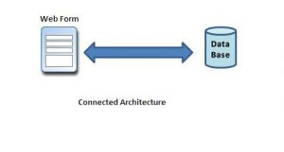

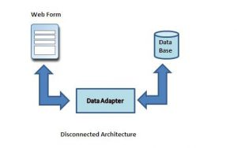

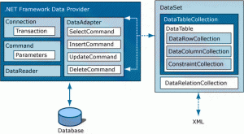

1. Describe the features of object-oriented design and multi-layer applications.

Answer:

Object-Oriented Design has 5 conceptual tools; encapsulation, data protection, inheritance, interface and polymorphism (8).

Multi-layer applications consist of separate areas which manage a related part of the program. Generally, there are 3 layers being the logic, data and user interface although more can exist (9)(10).

1. Provide an outline of relational database management systems.

Answer:

In basic terms it is a collection of data tables organized into columns (items of data) and rows (group of related data) which provide links to other tables via links using duplicate column data creating a one to one, one to many and many to many relationships. As a broader overview, it also covers language to interact with the data, security processes, data integrity processes and support of multiple users (11).

1. Describe object-oriented programming at an intermediate level.

Answer:

This is based on the concept where programs are formed around objects structures which contain data and related processes. The data within these objects are referred to as fields and the processes are called methods. Generally, languages which are defined as OOP are class-based where objects are created from a class definition. There are several principles that are derived around this concept; encapsulation (access is via the methods of the class), abstraction (they exhibit their internal functions as set by the programmer), inheritance (they can be derived from other classes) and polymorphism (where methods can be altered on children classes although created from a single parent).(12)(13)

1. Outline the principles of a Structured Query Language (SQL)

Answer:

SQL is used to access relational database management systems and therefore is considered domain specific. It has set statements which allow interaction with multiple groups of data and enables linking this data based upon a matching field. The language allows the addition, deletion, updating and displaying of information within the database. (14)

1. Name an open source Integrated Development Environment (IDE) that you have used and how you used it.

Answer:

Visual Studio 2019 using C# - I have used it for this course, and have written a small program to calculate price points on share price data that is manually entered in.

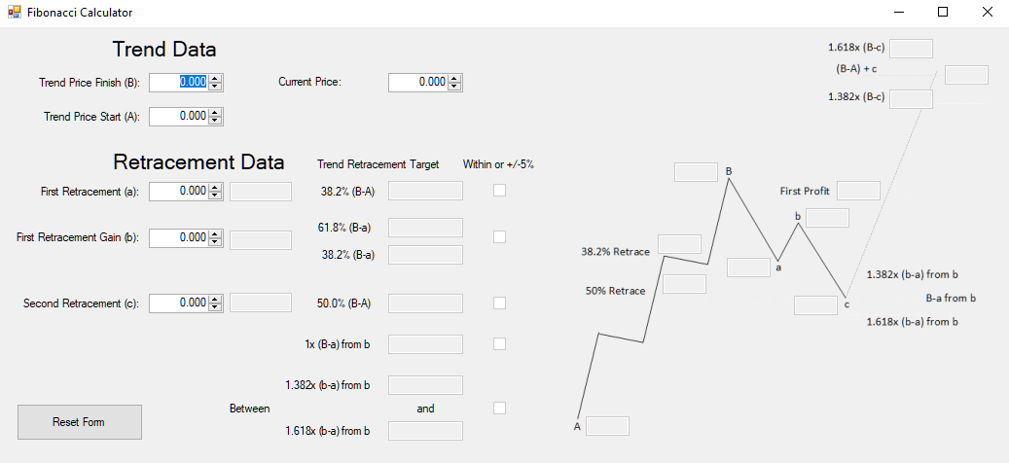

1. Describe the process of developing small-size applications.

Answer:

Agile development is the preferred approach when developing small applications. It is ideal for projects with a short time frame (around 30 days) and where the result is not exactly known but via collaboration with the client, the outcome is achieved. Testing is an ongoing process instead of at the end of the project which allows for bugs and errors to be identified during programming. Due to the quick turnaround, documentation is minimal. (15) It is demonstrated ideally in this graphic which compares a waterfall (traditional) approach to the agile approach.

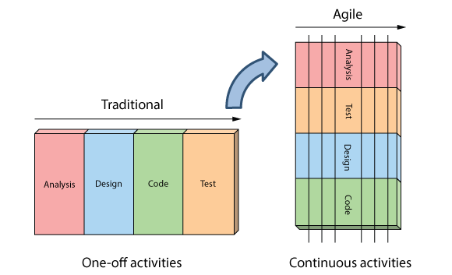(16)

1. Explain the function of the Data Access Layer (DAL) in a multi-layer application. Name two data-access application programming interfaces (API) for connecting to a database and how you would determine which API to use.

Answer:

The DAL provides the connection to the database and may incorporate additional functions which access and store data from within a program. The two main Data Access API’s to connect with a database is via the Object Relational Mapper (ORM) and Entity Framework methods. You would use Entity Framework when not constrained by a legacy data access approach and cases where you are, you would use ORM. ORM uses SQL similar commands (17).

References:

1. <https://en.wikipedia.org/wiki/User_interface>
2. <https://shortiedesigns.com/blog/10-top-principles-effective-web-design/>
3. <https://conversionxl.com/blog/universal-web-design-principles/>
4. <https://www.scitechnol.com/peer-review/current-trends-in-applications-for-softwarehardware-integration-eH3N.php?article_id=4975>
5. <https://www.tik.ee.ethz.ch/file/b64980517415068bd2ce3e14f2b19d44/fpl98.pdf>
6. <https://docs.microsoft.com/en-us/previous-versions/msp-n-p/ee658109%28v%3dpandp.10%29>
7. <http://blog.bestdotnettraining.com/connected-and-disconnected-architecture-bestdotnettraining-com/>
8. <http://www.selectbs.com/process-maturity/what-is-object-oriented-design>
9. <https://hub.packtpub.com/what-is-multi-layered-software-architecture/>
10. <https://www.codeproject.com/Articles/7766/Introduction-to-Object-Oriented-Tiered-Application>
11. <https://searchdatamanagement.techtarget.com/definition/RDBMS-relational-database-management-system>
12. <https://en.wikipedia.org/wiki/Object-oriented_programming>
13. <https://searchmicroservices.techtarget.com/definition/object-oriented-programming-OOP>
14. <https://en.wikipedia.org/wiki/SQL>
15. <https://www.exesoftware.ro/agile-and-waterfall-in-a-nutshell-2/>
16. <http://www.agilenutshell.com/agile_vs_waterfall>
17. <https://docs.microsoft.com/en-us/previous-versions/aspnet/ms178359(v=vs.110)>

**Next steps for you:**

You have now reached the end of this assessment.

Ensure that you have answered all of the above questions.

Upload this document to OpenSpace. Label your file your StudentNumber\_UIDB\_33130-03.docx. E.g. 665437\_UIDB\_33130-03.docx.

Your trainer will provide you with feedback for this assessment.